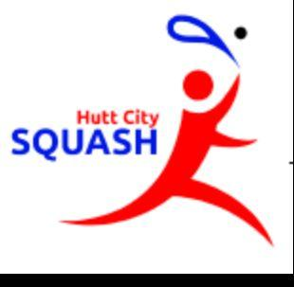
HUTT CITY SQUASH: COVID-19 Response
Frequently Asked Questions
As at: Monday 11th May
- Why has my membership been extended 2 months?
The complex has been closed since 21st March, it's important that members do not pay for not being able to play.
- Why are some members being offered a 10 month renewal, if they have a 1st April renewal date?
As many of our members have budgeted for and been paying their subs on the 1st April for many years, it is important to enable members to maintain this budget date to reduce further financial disruption on members.
- Is the club getting levy relief from SW, SNZ and FPS, if so, will this be passed onto members?
The committee unanimously agreed to offer all members a subs discount for this year, this was done prior to knowing if we would receive any rebate from SW, SNZ and FPS. The committee made this decision to a) provide a benefit to our members, but also b) It’s important that if we do receive a rebate that this is passed onto members through reduced subscriptions.
We are aware of SNZ offering a rebate, but are waiting to find if SW (likely) and FPS (unknown) will provide rebates on the levies we pay them.
Regardless of the total rebate received the Sub discount will remain as notified, in event we receive a greater rebate [per member] than equivalent discounted sub, the committee will decide how to apply this to benefit members, cover hardship or club events.
- Is the discount offered to current and new members wanting to renew or join?
Absolutely… The discount is there to help members come back and start playing our game after the long break, if you have friends or family keen to join then they get the same discount.
We are keen and passionate about ensuring members keep playing at Hutt City Squash, this is a small way of saying thanks for being patient.
- With Covid-19 level 2 announced when can we start playing again, what is allowed at FPS
We have not heard yet when we will be allowed back in the complex, it is run by HCC and we need their permission to re-enter the building. We have started working with FPS to ensure the guidelines announced by the government can be met to enable you back to start playing socially with your friends (in small groups obviously).
We will be introducing a Contact Tracing Sheet, refining the rules and guidelines for Safe playing.
Once we have this information we will let EVERYONE know the what and the how to start booking your games.
- When will we be able to play tournaments and interclub again?
HCS, like SW and all sports clubs are keen to get back into playing full time, but at this stage we must align to the Governments and SNZ guidelines, SNZ and SW are keen to get tournaments and interclub back up and running, once we have been given the all clear we will let everyone know. But rest assured the committee are working hard on planning for the time we are given the go ahead.

